Project Phase II Proposal

WalkAbout by Ryszard Kilarski (U81-39-8560)

# Response to Phase 1 Comments

* 1. **Summary Description**

When going on vacation, I like to keep track of where I’ve been, what photos I’ve taken at particular waypoints, and even create a map of where I’ve walked around.

Introducing: **WalkAbout**, the Android app that allows you walkabout and then talkabout your trip.

In this application, you will be able to create a “waypoint” (geotagged to your location), and then take (or add from the camera roll) as many photos as you like into it. You can add your own description to each waypoint, move photos between waypoints, and even “check in” to a particular area using Facebook. Additionally, you will be able to export your photos to your Camera Roll and also select a beginning and ending waypoint to produce a Google map of your path.

* 1. **I/O Examples**

|  |  |
| --- | --- |
| **Waypoint List**  The main user interface is a list of all the waypoints and the photographs within them. The user can scroll through all the waypoints and see all their photos.  Tapping on a particular photo displays the photo in full-screen mode. Swiping left or right in that mode scrolls you through all the photos in that waypoint.  The top of the waypoint displays the waypoint details: the description, date/time, and possibly location information.  Buttons display at the top of each waypoint to add additional images either from the camera roll or via the camera.  A button displays to take you to the viewpoint detail.  The Tools button accesses a settings page and other tools, such as “export all photos to camera roll”. |  |

|  |  |
| --- | --- |
| **Waypoint Add/Edit/Delete**  The Waypoint Add/Edit/Delete screen allows you to change the waypoint description, date/time, and even re-geotag/Facebook Check-in.  When adding a new waypoint, the date/time and geolocation will be automatically filled in for you.  (Not shown) This screen also contains the “Move Images To Another Waypoint” button. |  |

|  |  |
| --- | --- |
| **Waypoint Photo Move**  The Waypoint Photo Move screen allows you to select one or more photos in one waypoint, and move them to another. |  |

* 1. **Requirements**
     1. **Definite**
        1. Create a geotagged waypoint
        2. Add or take photos into the waypoint
        3. Ability to scroll and view all waypoints
     2. **Nice-to-do**
        1. Produce a Google Map from waypoints
        2. Facebook “check-in” integration
        3. Export waypoint to Facebook album (new or existing)
     3. **In the middle**
        1. Exporting waypoint photos to camera roll
        2. Edit existing waypoint (description, “check-in”, re-geotag…) or delete it
        3. Ability to move photos between waypoints
  2. **Android Features**

**Database Access**

*Requirements:* 1.3.1.1 and 1.3.1.2

The ability to create and save a waypoint and its photographs is central to the app.

**Camera**

*Requirements:* 1.3.1.2

The ability to access the camera to take photos is important when creating a waypoint. Alternatively, you should have the ability to access existing photos from the camera roll.

**GPS/Geotagging**

*Requirements:* 1.3.1.1 and 1.3.2.1 and 1.3.2.2 and 1.3.3.2

Access to the location services will allow attaching the GPS coordinates to each waypoint and to produce the Google map that outlines your path.

**Connectivity**

*Requirements:* 1.3.2.1 and 1.3.2.2 and 1.3.2.3 and 1.3.3.2  
Android connectivity (3G/4G/WiFi) will allow the app to access Facebook for check-in and uploading purposes, and allow the creation of the Google Map that will be the result of the path you took.

**Accelerometer/Orientation**

*Requirements:* 1.3.3.1 and 1.3.3.2 and 1.3.3.3

Changing the orientation on the device will take you to editing modes that allow you to edit your waystation information, move photos from one waystation to another.

|  |  |  |  |  |  |  |  |
| --- | --- | --- | --- | --- | --- | --- | --- |
|  | **D** | **C-** | **C+** | **B-** | **B+** | **A** |  |
| **1. Clarity** | Disorganized or hard-to-understand | | Satisfactory but some parts of the submission are disorganized or hard to understand | Generally organized and clear | Very clear, organized and persuasive presentation of ideas and designs | Exceptionally clear, organized and persuasive presentation of ideas and designs | A |
| **2. Technical Soundness** | Little understanding of, or insight into material technically | | Some understanding of material technically | Overall understanding of much material technically | Very good overall understanding of technical material, with some real depth | Excellent, deep understanding of technical material and its inter-relationships | B+ |
| **3. Thoroughness & Coverage** | Hardly covers any of the major relevant issues | | Covers some of the major relevant issues | Reasonable coverage of the major relevant areas | Thorough coverage of almost all of the major relevant issues | Exceptionally thorough coverage of all major relevant issues | A |
| **4. Relevance** | Mostly unfocused | Focus is off topic or on insubstantial or secondary issues | Only some of the content is meaningful and on topic | Most or all of the content is reasonably meaningful and on-topic | All of the content is reasonably meaningful and on-topic | All of the content is entirely relevant and meaningful | A |

# Final Requirements

## Definite Requirements

1. The App shall allow you to add a new Waypoint
   1. The Waypoint will be geotagged
   2. The Waypoint will have time, date, and a name.
2. The App shall allow you to edit an existing Waypoint
   1. Rename a Waypoint
   2. Re-geotag a Waypoint
   3. Change date/time
3. The App shall allow you to delete an existing Waypoint.
4. The App shall allow you to scroll and view Waypoints.
5. The App shall allow you to take photos with the device camera and add them to the Waypoint.
6. The App shall allow you to tap to view a photo fullscreen.
7. The App shall allow you to delete photos from a Waypoint.
8. The App shall allow you to produce a map from all the photos in a Waypoint.

## Nice To Do Requirements

1. The App shall allow you to “check in” a Waypoint using Facebook.
2. The App shall allow you to export all photos in a Waypoint to a Facebook album.
3. The App shall allow you to export all photos in a Waypoint to the device album.
4. The App shall allow you to move photos between Waypoints.
5. The App shall provide the ability to change the Waypoint Order By setting.
6. The App shall provide the ability to change the Photo Order By setting.
7. The App shall allow you to expand/collapse individual Waypoints in the list, only displaying the name/datetime.
8. The App shall allow you to change the order of photos in the Waypoint.

## Screen Shots

### Waypoint List

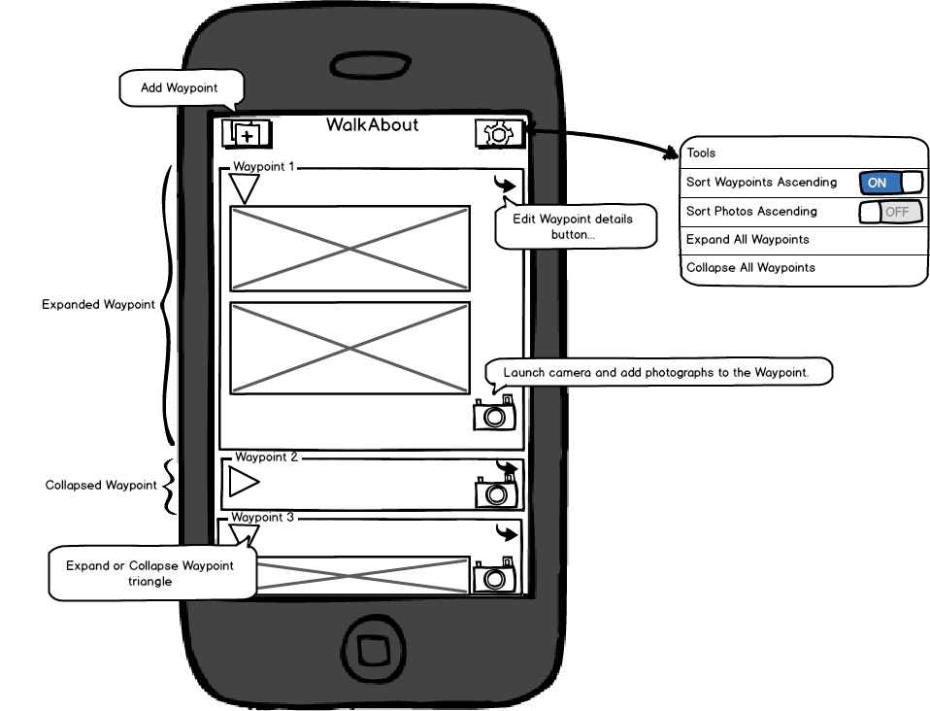

### Add/Edit Form

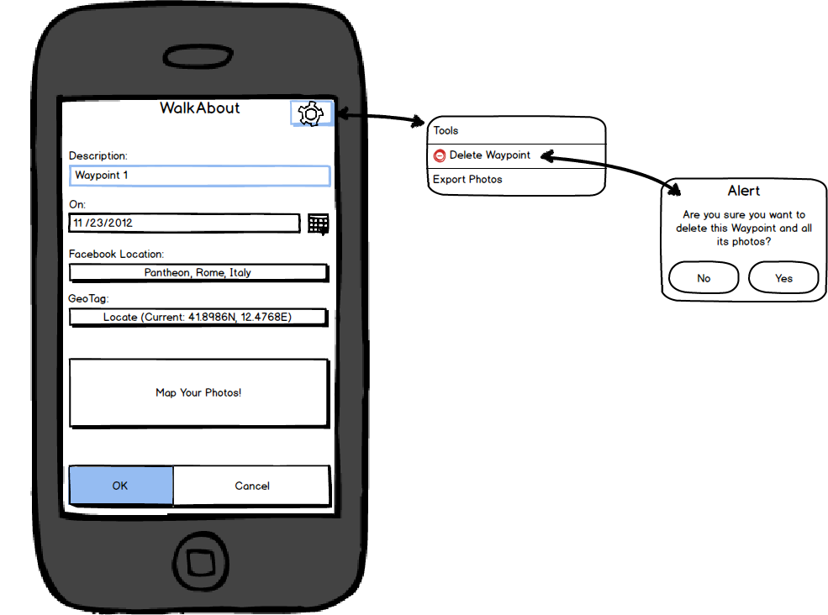

### Waypoint Map Form

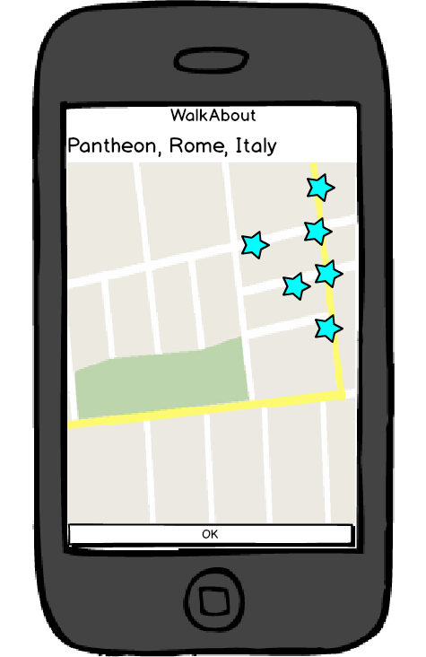

# Feature Cross-Reference

Provide a table with your requirement numbers D1, D2, ..., N1, N2, ... at the top, Android features at the left, and "x" in the table's body where applicable.

|  |  |  |  |  |  |  |  |  |  |  |  |  |  |  |  |  |  |
| --- | --- | --- | --- | --- | --- | --- | --- | --- | --- | --- | --- | --- | --- | --- | --- | --- | --- |
| Android Feature |  | Requirements | | | | | | | | | | | | | | | |
|  | D1 | D2 | D3 | D4 | D5 | D6 | D7 | D8 | N1 | N2 | N3 | N4 | N5 | N6 | N7 | N8 |
| Database Access | X | X | X |  | X |  | X | X | X | X | X | X |  |  |  | X |
| Camera |  |  |  |  | X | X |  |  |  |  |  |  |  |  |  |  |
| Local filesystem |  |  |  |  |  |  |  |  |  |  | X |  |  |  |  |  |
| GPS/Geotag | X | X |  |  |  |  |  | X |  |  |  |  |  |  |  |  |
| Data Connectivity |  |  |  |  |  |  |  | X | X |  |  |  |  |  |  |  |
| Accelerometer / Orientation |  |  |  |  |  |  |  |  |  |  |  |  |  |  |  |  |
| Touch/UI | X | X |  | X |  | X | X |  |  |  |  | X | X | X | X | X |
| Google Maps Integration |  |  |  |  |  |  |  | X |  |  |  |  |  |  |  |  |
| Facebook Integration |  |  |  |  |  |  |  |  | X | X |  |  |  |  |  |  |

# Design

## Screen Transition Diagram

This diagram shows the flow of screens from the central Waypoint List.

## D:\dev-eclipse-android\WalkAbout\doc\WalkAbout Screen Transition Diagram.jpg

## Object Relationship Diagram

This diagram shows the major data objects. (All properties can be assumed to have their appropriate getter and setter methods.)

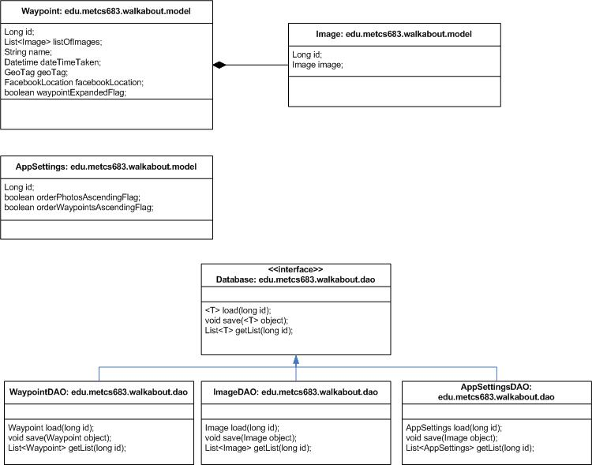

### Waypoint

The Waypoint is the main data object, containing a list of images as well as “miscellaneous” data about the Waypoint. This includes

* The Waypoint’s unique ID in the database,
* The Waypoint’s name,
* The date/time it was created,
* Its geotag,
* Its Facebook location,
* Whether it is visually expanded or contracted by the user.

### Image

The image object contains the photograph itself and a unique ID.

### AppSettings

The AppSettings object contains the system settings for the application.

### Database

The Database interface contains the methods needed by all the DAO objects to load, save, and get a list of those objects.

#### WaypointDAO

This object contains the methods to load, save, and get a list of Waypoints.

#### ImageDAO

This object contains the methods to load, save, and get a list of images.

#### AppSettingsDAO

This object contains the methods to load, save, and get the Application settings object.

## User Interface Object Relationship

This diagram shows the major UI objects and how they interface with the Data objects. (All properties can be assumed to have their appropriate getter and setter methods.)

# Partial Implementation of Risks

Work to avoid "show-stoppers" in your project.

4a. List, in order, what you consider the riskiest elements associated with (i) your definite requirements, and (ii) your nice-to-do requirements.

4b. Select the three riskiest elements. Using partial implementations to show evidence that you implemented enough to settle these risks. Ideally, these should cover all risks in your "definite" category. The "partial implementations" can be prototypes or even experiment code.

# Schedule

Explain the steps you intend to take to carry out the project. Show the completion of the stages. Include a schedule, as detailed as can be reasonably foreseen. Spread the effort evenly and try to allow for unforeseen obstacles.